Hello Middleton Families,
The Physical Education team is very excited to start the 2016-2017 school year. There have been many positive changes to the Physical Education program at Middleton. First and foremost the students at Middleton will have Physical Education every single day. Weekly every student will receive 155-165minutes of instruction from a certified Physical Education teacher. Middleton school has three P.E. teachers: Ms. Pappas, Mr. Bekkedal, and Mrs. Santefort. Meet the P.E. staff below.
Two days a week your child will attend P.E. Specials for 40-45 minutes and the other three days they will be in X-block for 25 minutes. P.E. Specials and X-block are two very different programs. X block will be a fitness based approach while P.E. Specials will be more team fundamentals and sport specific skills. Students are expected to wear gym shoes every single day as it is part of their participation grade, we recommend keeping a separate pair of gym shoes in their lockers to make sure they are never forgotten.
We are looking forward to meeting all the students and families of Middleton. If you have any questions or concerns on the new P.E. program please feel free to email any one of us.
MEET YOUR NEW ALL STAR P.E. TEAM
Ms. Pappas Mr. Bekkedal Mrs. Santefort
dpappas@sd735.org bbekkedal@sd735.org ksantefort@sd735.org
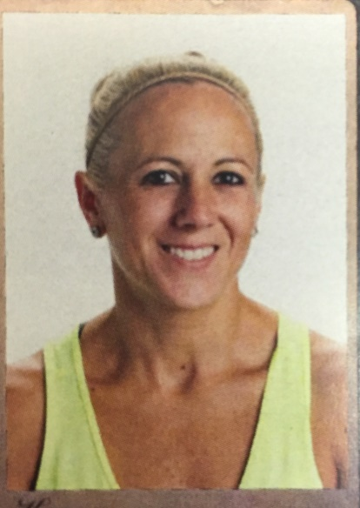

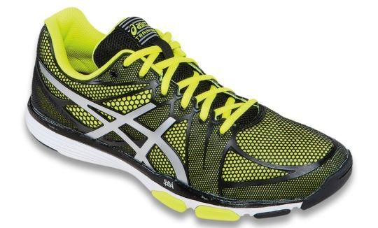

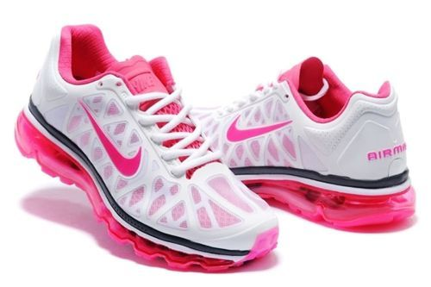

Students are required to wear supportive gym shoes with a rubber sole every single day to P.E. Students who do not have gym shoes will not be able to participate, which will result in loss of participation points for that day.

